Water Bill Collection App
Screen Flow and Descriptions
Updated Collector and Administrator Flow with QR Scanning
1 Screen Flow
2 Screen Description
2.1 Authentication
2.1.1 Login Screen
2.1.2 Register Screen
2.1.3 Reset Password Screen
2.2 Collector Features
2.2.1 Collector Dashboard Screen
2.2.2 Scan QR Screen
2.2.3 Customer Details Screen
2.2.4 View Complaints Screen
2.2.5 Record Meter Reading Screen
2.2.6 Generate Bill Screen
2.2.7 Collect Payment Screen
2.2.8 Collection History Screen
2.2.9 Bill Details Screen
2.2.10 Collector Settings Screen
2.3 Administrator Features
2.3.1 Admin Dashboard Screen
2.3.2 Manage Customers Screen
2.3.3 Manage Collectors Screen
2.3.4 Billing Management Screen
2.3.5 Payment Records Screen
2.3.6 View Reports Screen
2.3.7 Admin Settings Screen

1 Screen Flow
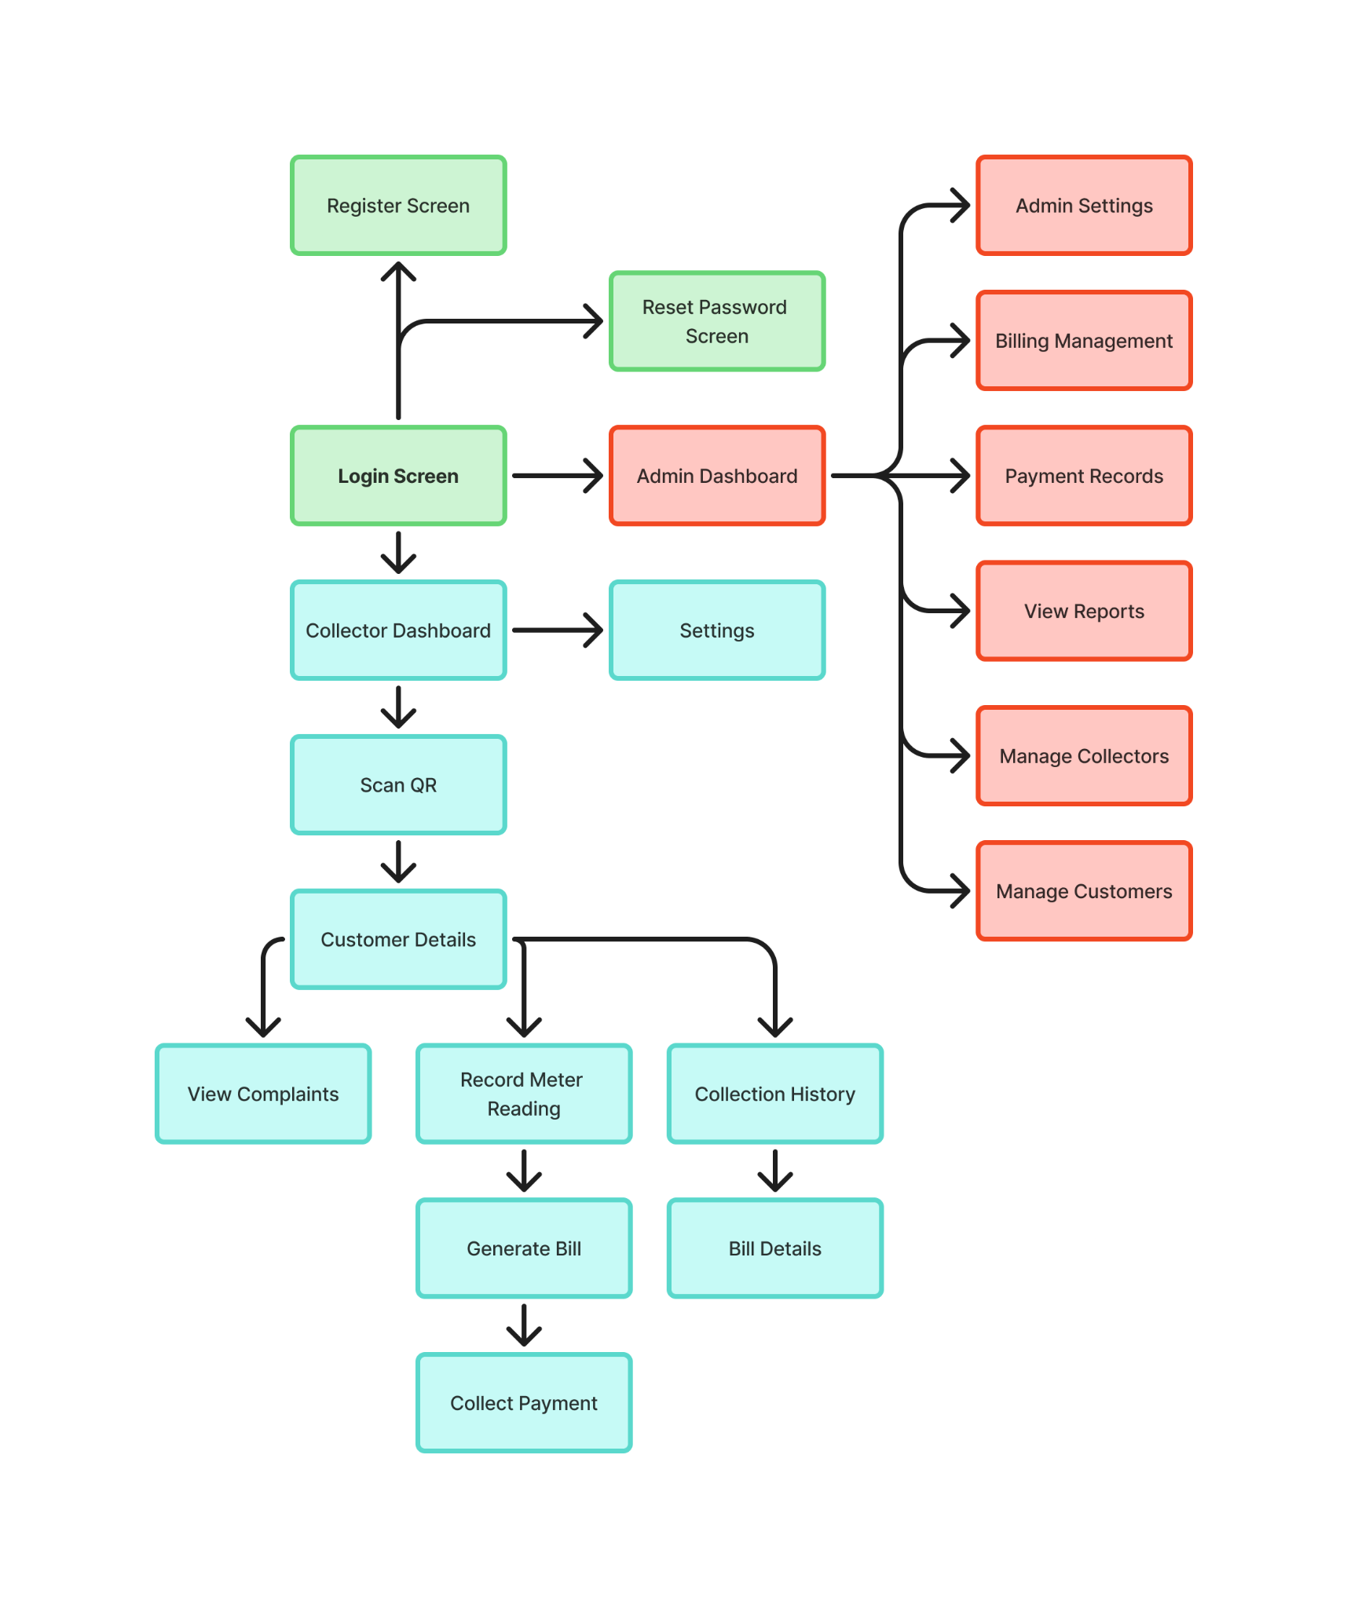
Figure 1. Updated Screen Flow for Collector and Administrator

2 Screen Description

2.1 Authentication

2.1.1 Login Screen
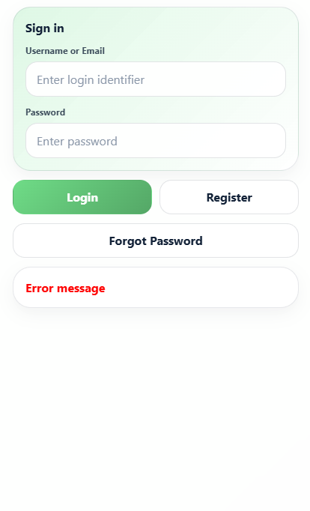
This screen allows the User to:
- Enter login credentials.
- Submit the login request for authentication.
- Access the Collector Dashboard or Admin Dashboard based on the authenticated role.
On this screen, s/he can also:
- Navigate to the Register Screen.
- Navigate to the Reset Password Screen.
- View validation or authentication error messages.
Table: Field Descriptions for Login Screen
Field Name | Description
Username / Email | Data type: string. Allows the user to enter a registered username or email address. Required.
Password | Data type: string. Masked password input. Required.
Login Button | Submits the login request and redirects the user based on role if authentication is successful.
Register Link | Redirects the user to the Register Screen.
Forgot Password Link | Redirects the user to the Reset Password Screen.
Error Message | Displays login failure messages such as invalid credentials, inactive account, or insufficient permission.

2.1.2 Register Screen
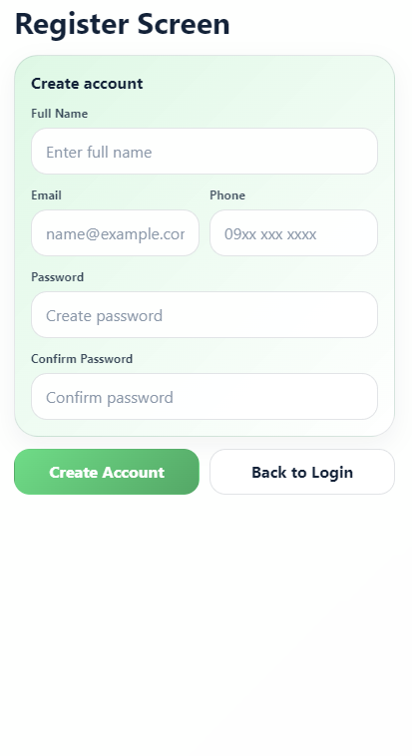
This screen allows the Guest to:
- Enter account information.
- Enter contact information.
- Submit registration information to create a new system account.
On this screen, s/he can also:
- Return to the Login Screen.
- View field validation messages.
- Clear entered information before submitting.
Table: Field Descriptions for Register Screen
Field Name | Description
Full Name | Data type: string. Stores the registrant’s full name. Required.
Email Address | Data type: string. Stores the registrant’s email address. Required and must be unique.
Phone Number | Data type: string. Stores the registrant’s phone number. Required and must be unique.
Requested Role | Data type: enumeration. Values: Collector, Admin. Defines the role requested during registration if self-registration is allowed.
Password | Data type: string. Masked input used to create the account password. Required.
Confirm Password | Data type: string. Must match the Password field.
Register Button | Submits the registration request.
Back to Login Link | Redirects the user back to the Login Screen.

2.1.3 Reset Password Screen
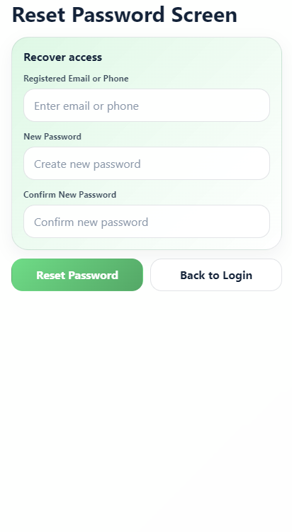
This screen allows the User to:
- Enter registered email address or phone number.
- Request a reset code or reset link.
- Create a new password after verification.
On this screen, s/he can also:
- Return to the Login Screen.
- Request another reset code if the previous code expires.
- View validation or verification error messages.
Table: Field Descriptions for Reset Password Screen
Field Name | Description
Email / Phone Number | Data type: string. Used to identify the user account requesting password recovery. Required.
Verification Code | Data type: string. Stores the OTP or reset code received by the user if OTP verification is used.
New Password | Data type: string. Masked input for the new password.
Confirm New Password | Data type: string. Must match the New Password field.
Send Code Button | Sends password reset code or reset instruction to the registered contact.
Reset Password Button | Submits the new password after verification.
Back to Login Link | Redirects the user back to the Login Screen.

2.2 Collector Features

2.2.1 Collector Dashboard Screen
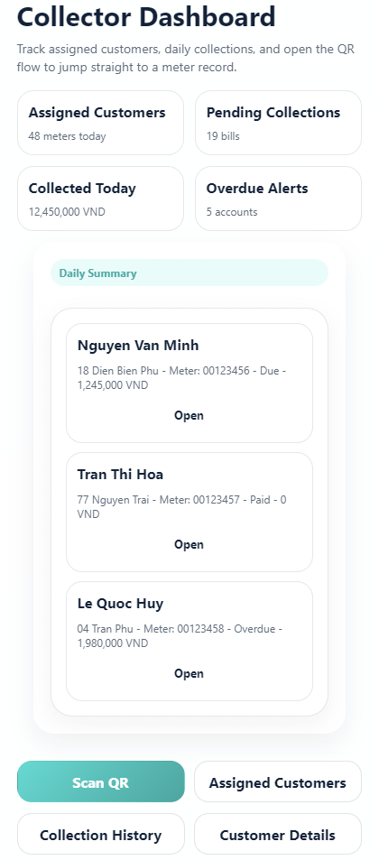
This screen allows the Collector to:
- View assigned collection summary.
- Access the QR scanning function to identify a customer meter.
- Access customer collection work from the dashboard.
On this screen, s/he can also:
- Navigate to collector Settings Screen.
- View daily collection summary.
- Return to dashboard after completing customer tasks.
Table: Field Descriptions for Collector Dashboard Screen
Field Name | Description
Collector Name | Displays the logged-in collector’s full name.
Assigned Customers Count | Data type: number. Displays the number of customers assigned to the collector.
Pending Collections | Data type: number. Displays bills that still need collection.
Collected Today | Data type: decimal. Displays total amount collected by the collector today.
Scan QR Button | Redirects to the Scan QR Screen.
Settings Button | Redirects to the Collector Settings Screen.
Summary Cards | Display daily task, payment, and pending bill statistics.

2.2.2 Scan QR Screen
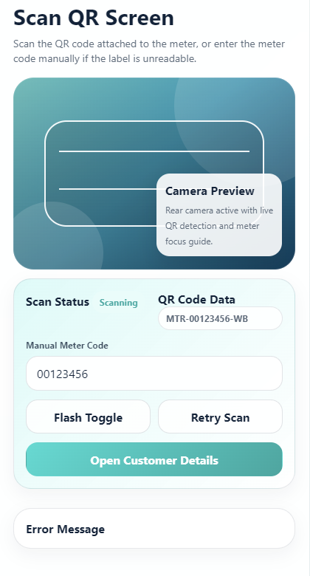
This screen allows the Collector to:
- Open the device camera for QR code scanning.
- Scan the QR code attached to the customer water meter.
- Navigate to Customer Details when the QR code is valid and matched to a customer record.
On this screen, s/he can also:
- Retry scanning if the QR code cannot be detected.
- Turn camera flash on or off if supported.
- Enter meter code manually if the QR code is damaged or unreadable.
Table: Field Descriptions for Scan QR Screen
Field Name | Description
Camera Preview | Displays the live camera view used to scan the meter QR code.
QR Code Data | Data type: string. Stores the scanned QR payload, such as meter ID or customer-meter token.
Scan Status | Data type: enumeration. Values: Scanning, Found, Invalid, Not Found.
Manual Meter Code | Data type: string. Allows manual entry of meter code when QR scanning fails.
Flash Toggle | Enables or disables camera flash if the device supports it.
Retry Button | Restarts the scanning process after a failed scan.
Open Customer Details Action | Redirects to Customer Details Screen after successful QR validation.
Error Message | Displays messages such as invalid QR code, unassigned meter, or customer not found.

2.2.3 Customer Details Screen
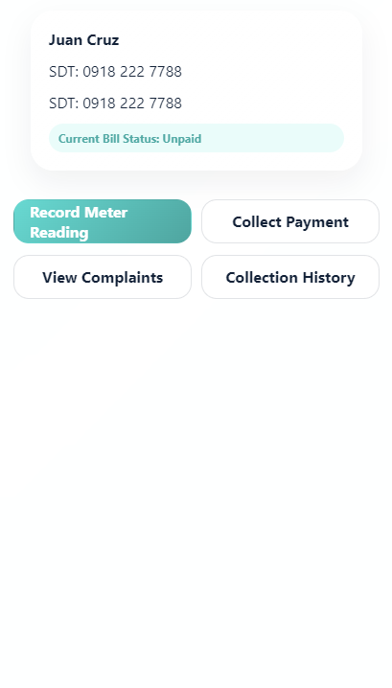
This screen allows the Collector to:
- View selected customer profile and meter information after QR scanning.
- Check current bill and payment status.
- Access meter reading, bill generation, complaints, and collection history.
On this screen, s/he can also:
- Call or contact the customer if contact details are available.
- Return to the Collector Dashboard or Scan QR Screen.
- View notes related to the customer account.
Table: Field Descriptions for Customer Details Screen
Field Name | Description
Customer Name | Displays the selected customer’s full name.
Phone Number | Displays customer contact number.
Address | Displays the customer’s service address.
Meter Number | Displays the assigned water meter number.
QR Code / Meter Token | Displays or stores the QR-linked identifier used to open this customer profile.
Current Bill Status | Data type: enumeration. Values: Paid, Unpaid, Overdue, Not Generated.
View Complaints Button | Redirects to the View Complaints Screen.
Record Meter Reading Button | Redirects to the Record Meter Reading Screen.
Collection History Button | Redirects to the Collection History Screen.

2.2.4 View Complaints Screen
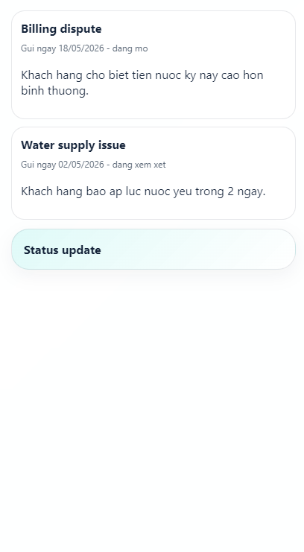
This screen allows the Collector to:
- View complaint list and complaint details for the selected customer.
- Check complaint type and submitted date.
- Review complaint evidence if attached.
On this screen, s/he can also:
- Update complaint status if allowed.
- Add handling notes.
- Return to the Customer Details Screen.
Table: Field Descriptions for View Complaints Screen
Field Name | Description
Complaint Type | Data type: enumeration. Values: Billing Dispute, Meter Issue, Water Supply Issue, Other.
Description | Displays complaint content submitted by the customer or recorded by staff.
Submitted Date | Data type: date/time. Displays when the complaint was submitted.
Complaint Status | Data type: enumeration. Values: Pending, In Progress, Resolved, Rejected.
Attachment Preview | Displays attached image or file if available.
Handling Note | Data type: string. Optional note added by collector or staff.
Back Button | Returns to the Customer Details Screen.

2.2.5 Record Meter Reading Screen
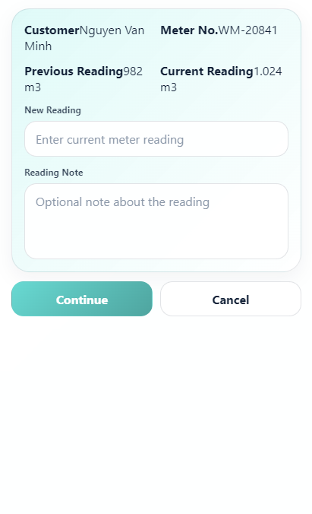
This screen allows the Collector to:
- View previous meter reading.
- Enter current meter reading for the scanned customer meter.
- Submit the reading to the system.
On this screen, s/he can also:
- Upload a meter photo as evidence.
- Cancel and return to Customer Details.
- View validation messages if the reading is invalid.
Table: Field Descriptions for Record Meter Reading Screen
Field Name | Description
Customer Name | Displays the selected customer’s full name.
Meter Number | Displays the assigned meter number.
Previous Reading | Data type: number. Displays the last approved meter value.
Current Reading | Data type: number. Must be greater than or equal to the previous reading.
Reading Date | Data type: date/time. Displays or stores the reading submission time.
Meter Photo | Data type: image/file. Optional or required evidence depending on system policy.
Reading Note | Data type: string. Optional note about the reading condition or meter issue.
Submit Reading Button | Submits the current reading and proceeds to the Generate Bill Screen if valid.
Cancel Button | Returns to the Customer Details Screen.

2.2.6 Generate Bill Screen
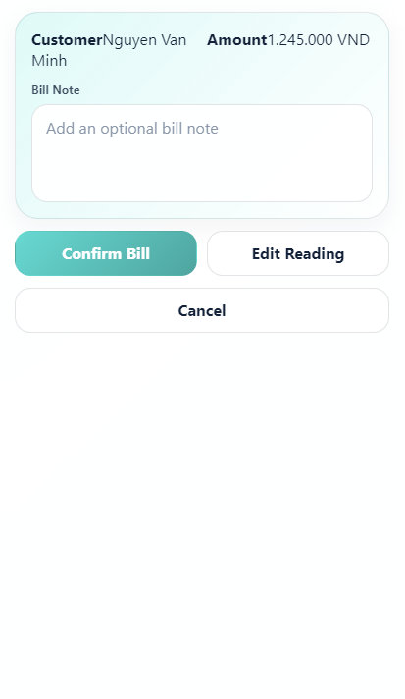
This screen allows the Collector to:
- Review previous and current meter readings.
- View calculated water usage and total amount.
- Confirm bill generation for the selected customer.
On this screen, s/he can also:
- Return to the Record Meter Reading Screen to correct reading information.
- Add bill note if needed.
- Cancel bill generation before confirmation.
Table: Field Descriptions for Generate Bill Screen
Field Name | Description
Customer Name | Displays the selected customer’s full name.
Previous Reading | Data type: number. Displays previous meter value.
Current Reading | Data type: number. Displays latest meter value.
Water Usage | Data type: number. Calculated usage for the billing period.
Rate Per Unit | Data type: decimal. Displays the rate used for calculation.
Total Amount | Data type: decimal. Displays calculated bill amount.
Due Date | Data type: date. Displays payment deadline.
Bill Note | Data type: string. Optional note stored with the generated bill.
Confirm Bill Button | Generates and saves the bill record, then redirects to the Collect Payment Screen.
Edit Reading Button | Returns to the Record Meter Reading Screen for correction.

2.2.7 Collect Payment Screen
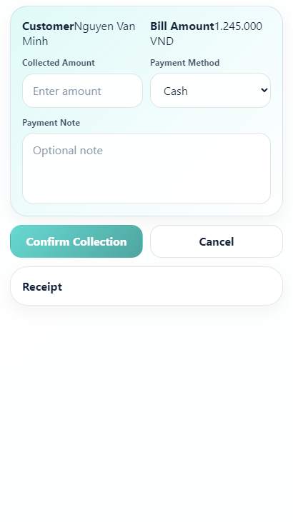
This screen allows the Collector to:
- View selected customer and bill amount.
- Enter collected amount and payment method.
- Confirm collection and update payment status.
On this screen, s/he can also:
- Add payment note.
- Cancel the collection action.
- Generate or view receipt after confirmation.
Table: Field Descriptions for Collect Payment Screen
Field Name | Description
Customer Name | Displays the customer’s full name.
Bill ID | Displays the bill identifier related to the payment.
Amount Due | Data type: decimal. Displays amount remaining to be paid.
Amount Paid | Data type: decimal. Stores amount collected by the collector.
Payment Method | Data type: enumeration. Values: Cash, Bank Transfer, E-wallet, Card.
Collection Date | Data type: date/time. Stores payment collection time.
Payment Note | Data type: string. Optional payment note.
Confirm Collection Button | Submits the collection record and updates bill/payment status.
Receipt Button | Displays or generates a receipt after payment is confirmed.

2.2.8 Collection History Screen
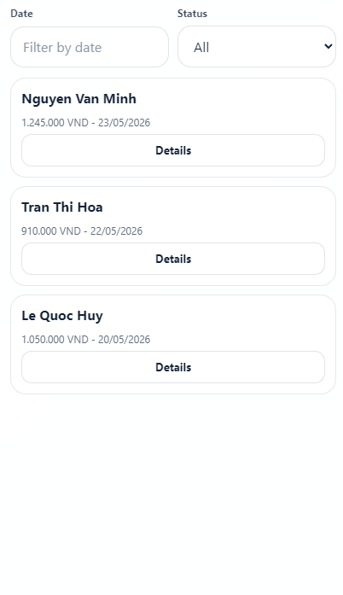
This screen allows the Collector to:
- View list of collection records for the selected customer.
- Check bill amount, payment status, and collection date.
- Open a selected record for bill details.
On this screen, s/he can also:
- Filter history by date or payment status.
- Search collection records.
- Return to the Customer Details Screen.
Table: Field Descriptions for Collection History Screen
Field Name | Description
Date Filter | Data type: date range. Filters collection records by date.
Status Filter | Data type: enumeration. Values: All, Paid, Unpaid, Overdue, Cancelled.
Bill Month | Displays the billing month related to the collection record.
Customer Name | Displays the customer related to the collection.
Amount Collected | Data type: decimal. Displays payment amount collected.
Payment Method | Data type: enumeration. Displays the method used.
Collection Date | Data type: date/time. Displays the time of collection.
View Detail Button | Opens the selected Bill Details Screen.

2.2.9 Bill Details Screen
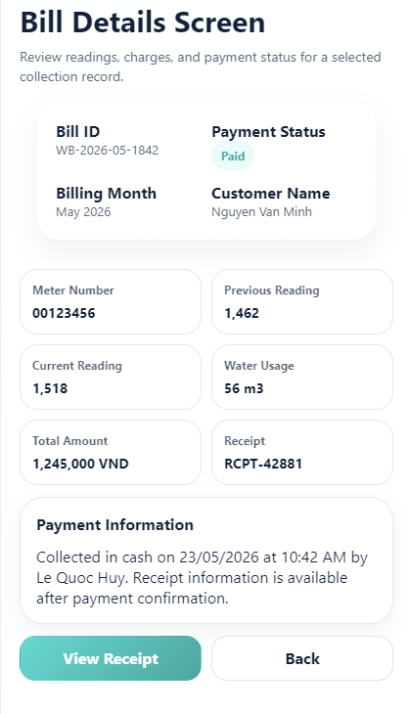
This screen allows the Collector to:
- View detailed information of the selected bill from collection history.
- Check meter readings, water usage, total amount, and payment status.
- Review payment information linked to the bill.
On this screen, s/he can also:
- View receipt information if payment has been completed.
- Return to the Collection History Screen.
- Report or note abnormal billing information if supported.
Table: Field Descriptions for Bill Details Screen
Field Name | Description
Bill ID | Displays the unique identifier of the selected bill.
Billing Month | Data type: string/date. Displays the billing period.
Customer Name | Displays the customer related to the bill.
Meter Number | Displays the water meter number used for the bill.
Previous Reading | Data type: number. Displays previous meter value.
Current Reading | Data type: number. Displays current meter value.
Water Usage | Data type: number. Displays calculated usage.
Total Amount | Data type: decimal. Displays final bill amount.
Payment Status | Data type: enumeration. Values: Paid, Unpaid, Overdue, Cancelled.
Receipt Button | Displays receipt information if the bill has been paid.
Back Button | Returns to the Collection History Screen.

2.2.10 Collector Settings Screen
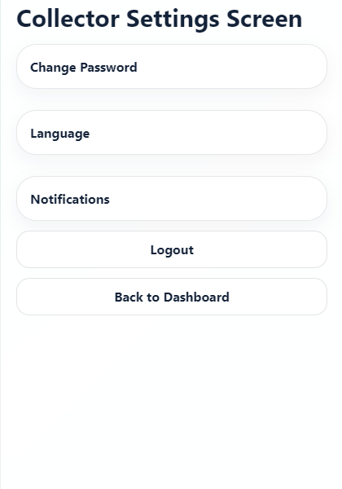
This screen allows the Collector to:
- View collector account settings.
- Update notification preferences.
- Manage account security options.
On this screen, s/he can also:
- Change password.
- Log out of the application.
- Return to the Collector Dashboard.
Table: Field Descriptions for Collector Settings Screen
Field Name | Description
Notification Toggle | Enables or disables task and collection reminders.
Language Setting | Allows selection of application language if supported.
Change Password Option | Redirects to password update functionality.
Logout Button | Logs the collector out of the application.
Back Button | Returns to the Collector Dashboard.

2.3 Administrator Features

2.3.1 Admin Dashboard Screen
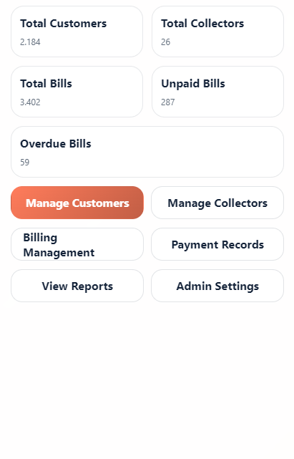
This screen allows the Admin to:
- View system summary statistics.
- Monitor customers, collectors, bills, payments, and reports.
- Access management functions from the dashboard.
On this screen, s/he can also:
- Navigate to Admin Settings.
- View recent payment or billing activity.
- Return to the dashboard after completing an admin task.
Table: Field Descriptions for Admin Dashboard Screen
Field Name | Description
Total Customers | Data type: number. Displays the number of registered customers.
Total Collectors | Data type: number. Displays the number of registered collectors.
Total Bills | Data type: number. Displays total bills generated.
Total Revenue | Data type: decimal. Displays total collected amount.
Unpaid Bills | Data type: number. Displays number of unpaid bills.
Overdue Bills | Data type: number. Displays number of overdue bills.
Manage Customers Button | Redirects to the Manage Customers Screen.
Manage Collectors Button | Redirects to the Manage Collectors Screen.
Billing Management Button | Redirects to the Billing Management Screen.
Payment Records Button | Redirects to the Payment Records Screen.
View Reports Button | Redirects to the View Reports Screen.
Admin Settings Button | Redirects to the Admin Settings Screen.

2.3.2 Manage Customers Screen
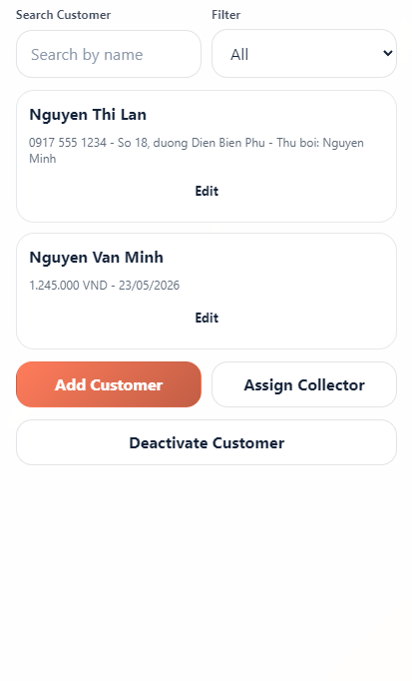
This screen allows the Admin to:
- View customer list.
- Add, edit, activate, or deactivate customer accounts.
- Assign or update collectors and QR-enabled meter records for customers.
On this screen, s/he can also:
- Search and filter customer records.
- View customer billing and payment summary.
- Generate, view, download, or print QR codes for customer meters.
Table: Field Descriptions for Manage Customers Screen
Field Name | Description
Search Customer | Data type: string. Allows searching by customer name, phone number, address, or meter number.
Status Filter | Data type: enumeration. Values: All, Active, Inactive.
Customer Name | Displays customer’s full name.
Phone Number | Displays customer’s phone number.
Address | Displays registered water service address.
Meter Number | Displays assigned meter number.
QR Code Status | Data type: enumeration. Values: Generated, Not Generated, Disabled.
Assigned Collector | Displays collector assigned to the customer.
Add Customer Button | Opens the form for creating a new customer.
Edit Button | Opens selected customer information for editing.
Assign Collector Button | Allows admin to assign or change collector.
Generate QR Code Button | Creates or refreshes the QR code linked to the customer meter.
Download / Print QR Button | Downloads or prints the QR code for placement on the water meter.
Deactivate Button | Deactivates the selected customer account.

2.3.3 Manage Collectors Screen
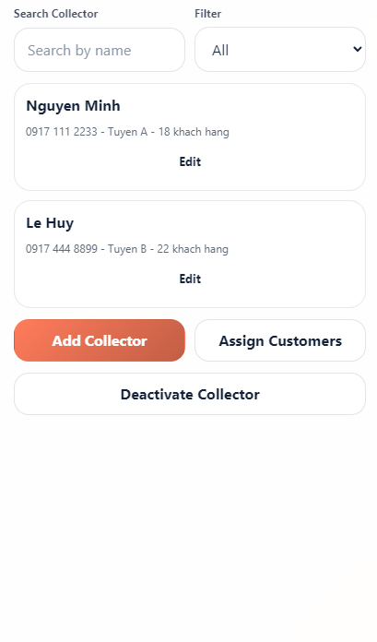
This screen allows the Admin to:
- View collector list.
- Add, edit, activate, or deactivate collector accounts.
- Assign customers or service areas to collectors.
On this screen, s/he can also:
- Search and filter collector records.
- View collector performance summary.
- Reassign customers when a collector is inactive.
Table: Field Descriptions for Manage Collectors Screen
Field Name | Description
Search Collector | Data type: string. Allows searching by collector name, phone number, or assigned area.
Status Filter | Data type: enumeration. Values: All, Active, Inactive.
Collector Name | Displays collector’s full name.
Phone Number | Displays collector’s phone number.
Assigned Area | Displays area or route assigned to the collector.
Assigned Customers Count | Data type: number. Displays number of assigned customers.
Add Collector Button | Opens the form for creating a collector account.
Edit Button | Opens selected collector information for editing.
Assign Customers Button | Allows admin to assign customers to the collector.
Deactivate Button | Deactivates selected collector account.

2.3.4 Billing Management Screen
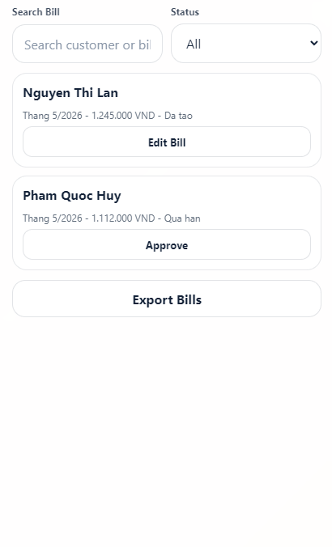
This screen allows the Admin to:
- View generated bills.
- Review or adjust bill information.
- Track bill payment status and overdue bills.
On this screen, s/he can also:
- Filter bills by month, customer, collector, or status.
- Approve generated bills if approval is required.
- Export bill list for reporting.
Table: Field Descriptions for Billing Management Screen
Field Name | Description
Search Bill | Data type: string. Allows searching by bill ID, customer name, or meter number.
Status Filter | Data type: enumeration. Values: All, Paid, Unpaid, Overdue, Pending Approval, Cancelled.
Customer Name | Displays customer related to the bill.
Water Usage | Data type: number. Displays usage for the billing period.
Total Amount | Data type: decimal. Displays final bill amount.
Due Date | Data type: date. Displays payment deadline.
Bill Status | Data type: enumeration. Displays current bill status.
Edit Bill Button | Allows admin to correct or adjust selected bill information.
Approve Button | Approves selected bill if approval workflow is enabled.
Export Button | Exports bill data if supported.

2.3.5 Payment Records Screen
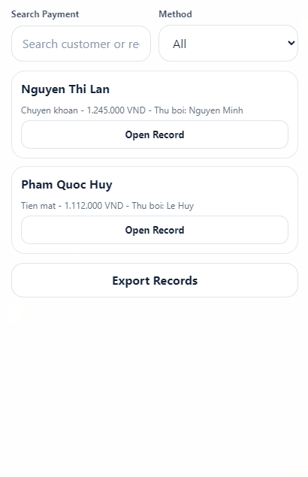
This screen allows the Admin to:
- View all payment transactions.
- Check payment status, amount, method, and collection date.
- Open a payment record for detail review.
On this screen, s/he can also:
- Filter payments by date, customer, collector, or method.
- Search payment transactions.
- Export payment records for accounting or reporting.
Table: Field Descriptions for Payment Records Screen
Field Name | Description
Search Payment | Data type: string. Allows searching by payment ID, bill ID, customer name, or collector name.
Method Filter | Data type: enumeration. Values: All, Cash, Bank Transfer, E-wallet, Card.
Customer Name | Displays customer who made the payment.
Amount Paid | Data type: decimal. Displays payment amount.
Payment Method | Displays selected payment method.
Collected By | Displays collector name if payment was collected by staff.
Payment Date | Data type: date/time. Displays transaction time.
Payment Status | Data type: enumeration. Values: Successful, Failed, Pending, Cancelled.
View Detail Button | Opens the selected payment record.

2.3.6 View Reports Screen
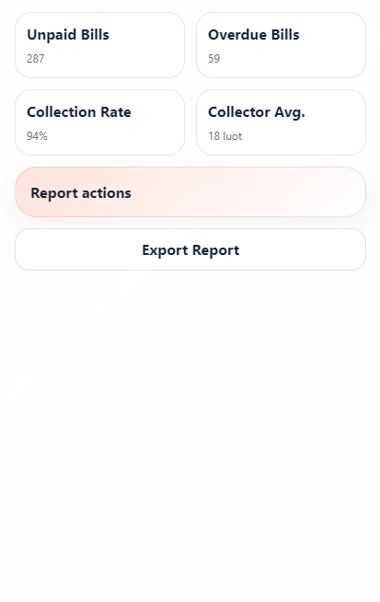
This screen allows the Admin to:
- View monthly revenue report.
- View unpaid and overdue bill reports.
- View collector performance summary.
On this screen, s/he can also:
- Filter report data by date range or area.
- Export reports to file if supported.
- Print report summary if supported.
Table: Field Descriptions for View Reports Screen
Field Name | Description
Report Type | Data type: enumeration. Values: Revenue, Unpaid Bills, Overdue Bills, Water Usage, Collector Performance.
Date Range | Data type: date range. Defines the report period.
Area Filter | Data type: string/enumeration. Filters report data by service area if available.
Collector Filter | Data type: string/enumeration. Filters performance data by collector.
Report Summary | Displays key totals and metrics for selected report type.
Report Table | Displays detailed report records.
Export Button | Exports the selected report if supported.
Print Button | Prints the report if supported.

2.3.7 Admin Settings Screen
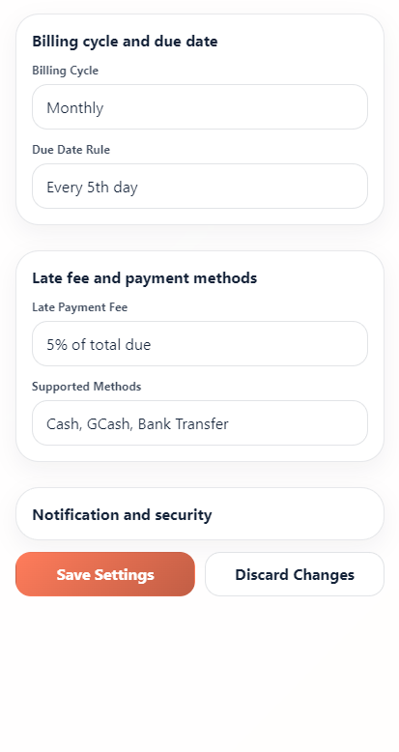
This screen allows the Admin to:
- Manage water rate configuration.
- Manage billing cycle and due date rules.
- Configure late payment fee and supported payment methods.
On this screen, s/he can also:
- Manage notification settings.
- Change admin account security settings.
- Return to Admin Dashboard.
Table: Field Descriptions for Admin Settings Screen
Field Name | Description
Water Rate Per Unit | Data type: decimal. Defines the price per water usage unit.
Billing Cycle | Data type: enumeration/date rule. Defines how often bills are generated.
Default Due Days | Data type: number. Defines number of days before a bill becomes due.
Late Payment Fee | Data type: decimal. Defines additional charge after due date if applicable.
Payment Methods | Data type: multi-selection. Defines available payment methods.
Notification Template | Defines message content for billing, overdue, and payment reminders.
Save Settings Button | Saves updated system settings.
Cancel Button | Discards unsaved changes and returns to previous screen.
Logout Button | Logs the admin out of the system.

